

**Misr University for Science and Technology**

**Information Technology College**

|  |  |
| --- | --- |
| **Academic Year: 2022-2023** | **Semester: Fall /2022-2023** |
| **Course Code: IS 402** | **Course Title: internet Technology** |
| **Department: Computer Science** | **Course Instructor: Dr:Reem hamdy** |

|  |  |  |
| --- | --- | --- |
| Name | ID | Level |
| Zyad Mostafa | 89481 | 4 |
| Hesham Saleh | 89581 | 4 |
| Mohamed Tarek | 89610 | 4 |
| Mohamed Osama | 89402 | 4 |

**Topic: Football Booking website**

**Presented to:**

**Dr:Reem hamdy**

**T.A:Mai Mohamed & Amany Mohamed**

# **1-Introduction**

Football is the most well-known sport around the whole world and most people Watch, play and encourages it and most of us if not all are playing it daily in Everywhere you can imagine, in the streets, colleges, clubs, beach and etc. And daily we go to some available stadiums in our local areas to play it in a Similar environment to the ones we see in the TV or on internet but most of The time those stadiums are not available or busy due to other reservations so We thought about a website app that will end all of this problems forever In the stadium is a website application which will make you reserve any of the Available stadiums near your local area or in where else you like, and also you can See which stadiums are available and where its location is, also you can search for Your favorite stadium among a wide variety of available stadiums at the website in Addition to modify or cancelling you reservation at any time you want to, so it’s Funnier, easier and safer with in the stadium so what are you waiting for go and Get your reservation now and enjoy with your friends.



# **2-Internet Technologies**

Internet Technologies is a technical field that covers the necessary skills to develop applications on the Internet or Internet based systems, harnessing e-commerce, cloud, mobile, and Web based technologies. This specialisation is being offered under the Bachelor of Information Technology (Hons) with dual award degree from Taylor's University and University of the West of England, Bristol. Upon completion of this specialization/extension, students should be able to develop applications using technologies and software that are used on the Internet. This would help students in driving their passion of being Internet Savvy or to expand their job prospects as Internet Technology Specialist, Internet Technologist, Internet Technology Solutions Architect, Internet Technologies Support Analyst, Internet Technology Systems Analyst, Internet Technology Support, Internet Technology Infrastructure Support, and etc.

For example:

1. Videos
2. Images
3. Audio
4. Maps
5. Publications
6. Blogs

And in this project we used

* Videos
* Images
* Audio
* Blogs

# **3-Search Engine**

# **What is a Search Engine?**

A search engine is a web-based tool that enables users to locate information on the World Wide Web. Popular examples of search engines are Google, Yahoo!, and MSN Search. Search engines utilize automated software applications (referred to as robots, bots, or spiders) that travel along the Web, following links from page to page, site to site. The information gathered by the spiders is used to create a searchable index of the Web[13].

## **How do search engines work?**

Every search engine uses different complex mathematical formulas to generate search results. The results for a specific query are then displayed on the SERP. Search engine algorithms take the key elements of a web page, including the page title, content and keyword density, and come up with a ranking for where to place the results on the pages. Each search engine’s algorithm is unique, so a top ranking on Yahoo! does not guarantee a prominent ranking on Google, and vice versa. To make things more complicated, the algorithms used by search engines are not only closely guarded secrets, they are also constantly undergoing modification and revision. This means that the criteria to best optimize a site with must be surmised through observation, as well as trial and error — and not just once, but continuously. Gimmicks less reputable SEO firms tout as the answer to better site rankings may work at best for only a short period before the search engine’s developers become wise to the tactics and change their algorithm. More likely, sites using these tricks will be labeled as spam by the search engines and their rankings will plummet. Search engines only “see” the text on web pages, and use the underlying HTML structure to determine relevance. Large photos, or dynamic Flash animation mean nothing to search engines, but the actual text on your pages does. It is difficult to build a Flash site that is as friendly to search engines; as a result, Flash sites will tend not to rank as high as sites developed with well coded HTML and CSS (Cascading Style Sheets — a complex mechanism for adding styles to website pages above and beyond regular HTML). If the terms you want to be found by do not appear in the text of your website, it will be very difficult for your website to yield high placement in the SERPs.

Reference

For example:

* Google
* Yahoo
* Baidu
* AOL
* Ask.com
* Excite
* Bing
* Yandex
* CC Search
* Swisscows
* DuckDuckGo
* StartPage
* Search Encrypt
* Gibiru
* OneSearch
* Wiki.com
* Boardreader
* giveWater
* Ekoru
* Ecosia
* SlideShare
* Internet Archive
* Brave
* Neeva

# **4-Internet Of Things(IOT)**

The Internet of things (IoT) describes physical objects (or groups of such objects) with [sensors](https://en.wikipedia.org/wiki/Sensor), processing ability, [software](https://en.wikipedia.org/wiki/Software) and other technologies that connect and exchange data with other devices and systems over the [Internet](https://en.wikipedia.org/wiki/Internet) or other communications networks.[[1]](https://en.wikipedia.org/wiki/Internet_of_things#cite_note-Linux_Things-1)[[2]](https://en.wikipedia.org/wiki/Internet_of_things#cite_note-Linux_21OSP-2)[[3]](https://en.wikipedia.org/wiki/Internet_of_things#cite_note-IqTU-3)[[4]](https://en.wikipedia.org/wiki/Internet_of_things#cite_note-4)[[5]](https://en.wikipedia.org/wiki/Internet_of_things#cite_note-5) Internet of things has been considered a [misnomer](https://en.wikipedia.org/wiki/Misnomer) because devices do not need to be connected to the public internet, they only need to be connected to a network[[6]](https://en.wikipedia.org/wiki/Internet_of_things#cite_note-6) and be individually addressable.[[7]](https://en.wikipedia.org/wiki/Internet_of_things#cite_note-7)[[8]](https://en.wikipedia.org/wiki/Internet_of_things#cite_note-8)

The field has evolved due to the convergence of multiple [technologies](https://en.wikipedia.org/wiki/Technologies), including [ubiquitous computing](https://en.wikipedia.org/wiki/Ubiquitous_computing), [commodity](https://en.wikipedia.org/wiki/Commodity) [sensors](https://en.wikipedia.org/wiki/Sensors), increasingly powerful [embedded systems](https://en.wikipedia.org/wiki/Embedded_system), as well as [machine learning](https://en.wikipedia.org/wiki/Machine_learning).[[9]](https://en.wikipedia.org/wiki/Internet_of_things#cite_note-ast-9) Traditional fields of [embedded systems](https://en.wikipedia.org/wiki/Embedded_system), [wireless sensor networks](https://en.wikipedia.org/wiki/Wireless_sensor_network), control systems, [automation](https://en.wikipedia.org/wiki/Automation) (including [home](https://en.wikipedia.org/wiki/Home_automation) and [building automation](https://en.wikipedia.org/wiki/Building_automation)), independently and collectively enable the Internet of things.[[10]](https://en.wikipedia.org/wiki/Internet_of_things#cite_note-aut-10) In the consumer market, IoT technology is most [synonymous](https://en.wikipedia.org/wiki/Synonymous_(disambiguation)) with products pertaining to the concept of the "[smart home](https://en.wikipedia.org/wiki/Smart_home_technology)", including devices and [appliances](https://en.wikipedia.org/wiki/Home_appliance) (such as lighting fixtures, [thermostats](https://en.wikipedia.org/wiki/Thermostats), home [security systems](https://en.wikipedia.org/wiki/Security_systems), cameras, and other home appliances) that support one or more common ecosystems, and can be controlled via devices associated with that ecosystem, such as [smartphones](https://en.wikipedia.org/wiki/Smartphone) and [smart speakers](https://en.wikipedia.org/wiki/Smart_speaker). IoT is also used in [healthcare systems](https://en.wikipedia.org/wiki/Health_system).[[11]](https://en.wikipedia.org/wiki/Internet_of_things#cite_note-11)

There are a number of concerns about the risks in the growth of IoT technologies and products, especially in the areas of [privacy](https://en.wikipedia.org/wiki/Digital_privacy) and [security](https://en.wikipedia.org/wiki/Digital_security), and consequently, industry and governmental moves to address these concerns have begun, including the development of international and local standards, guidelines, and regulatory frameworks.[[12]](https://en.wikipedia.org/wiki/Internet_of_things#cite_note-12)

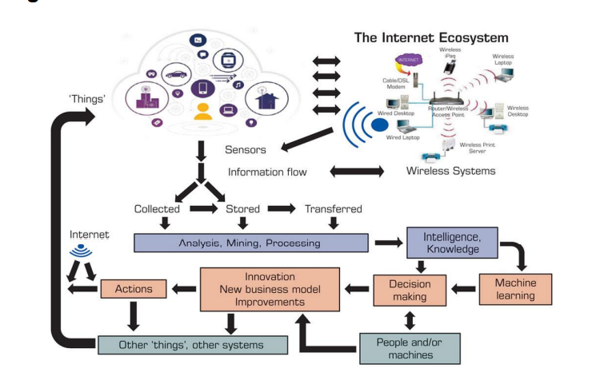

Figure 1.How IoT Works

# **5- screenshots**

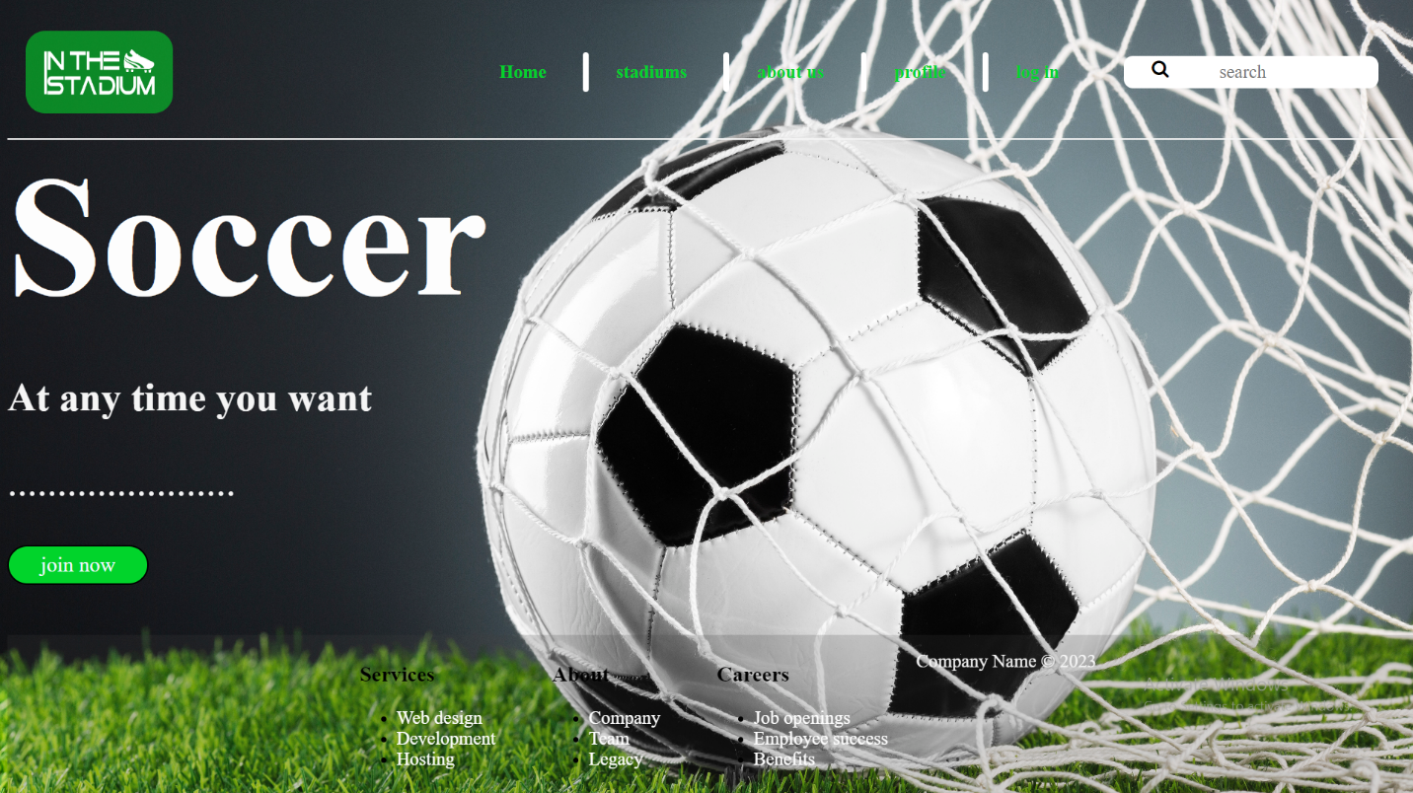

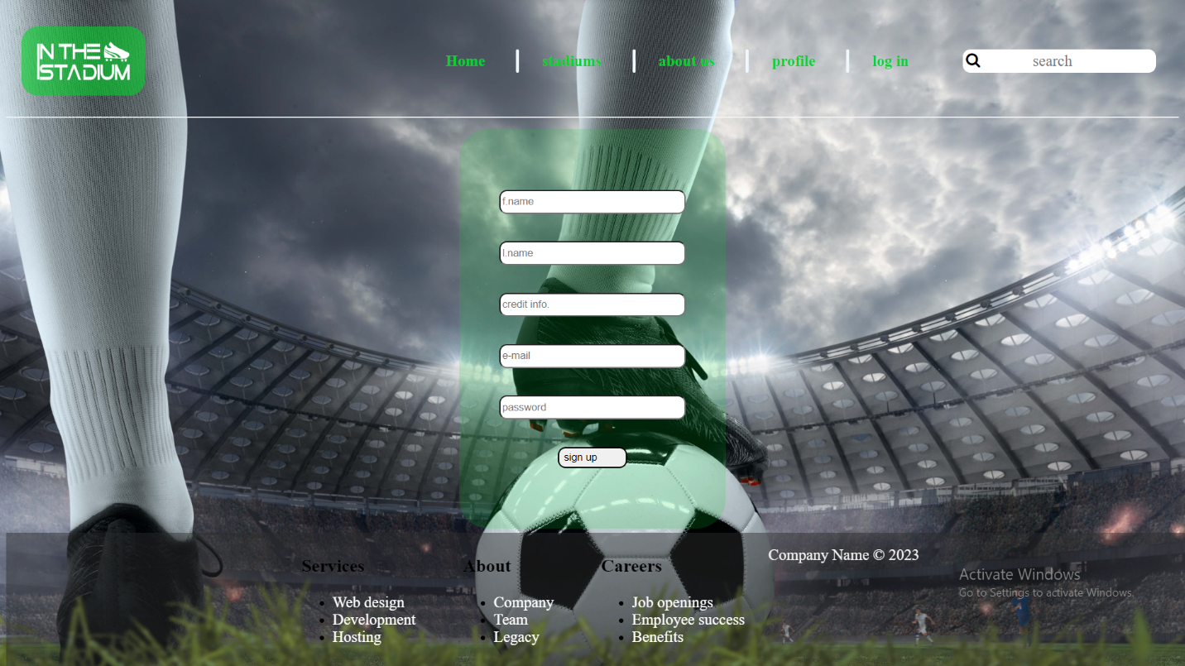

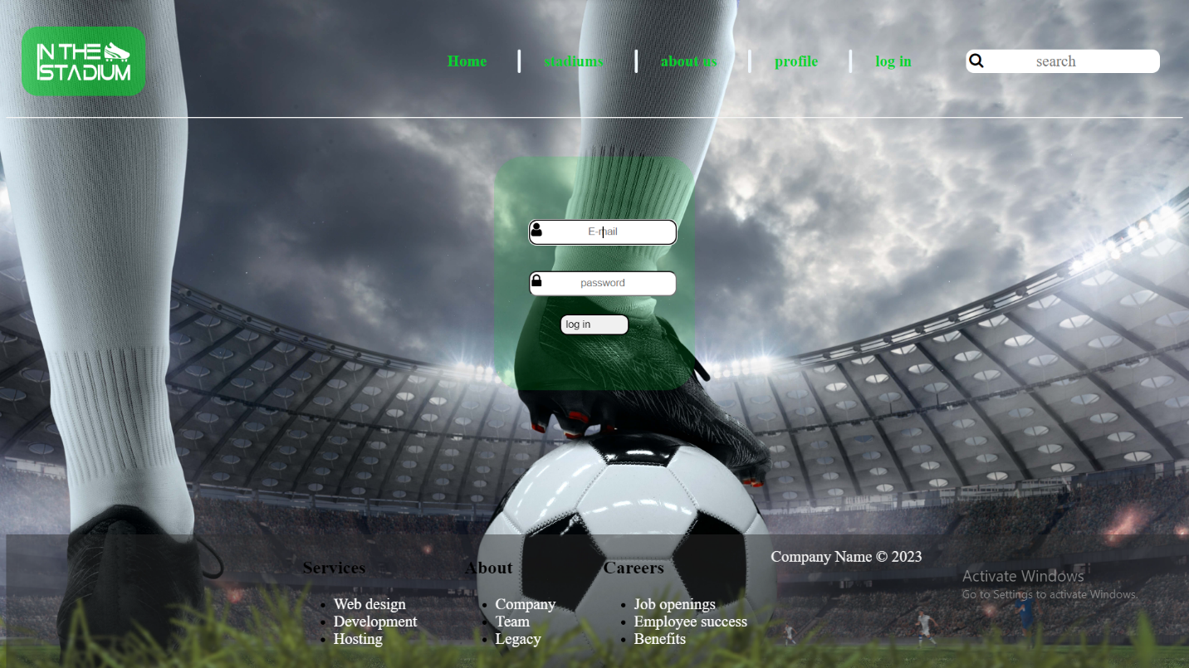

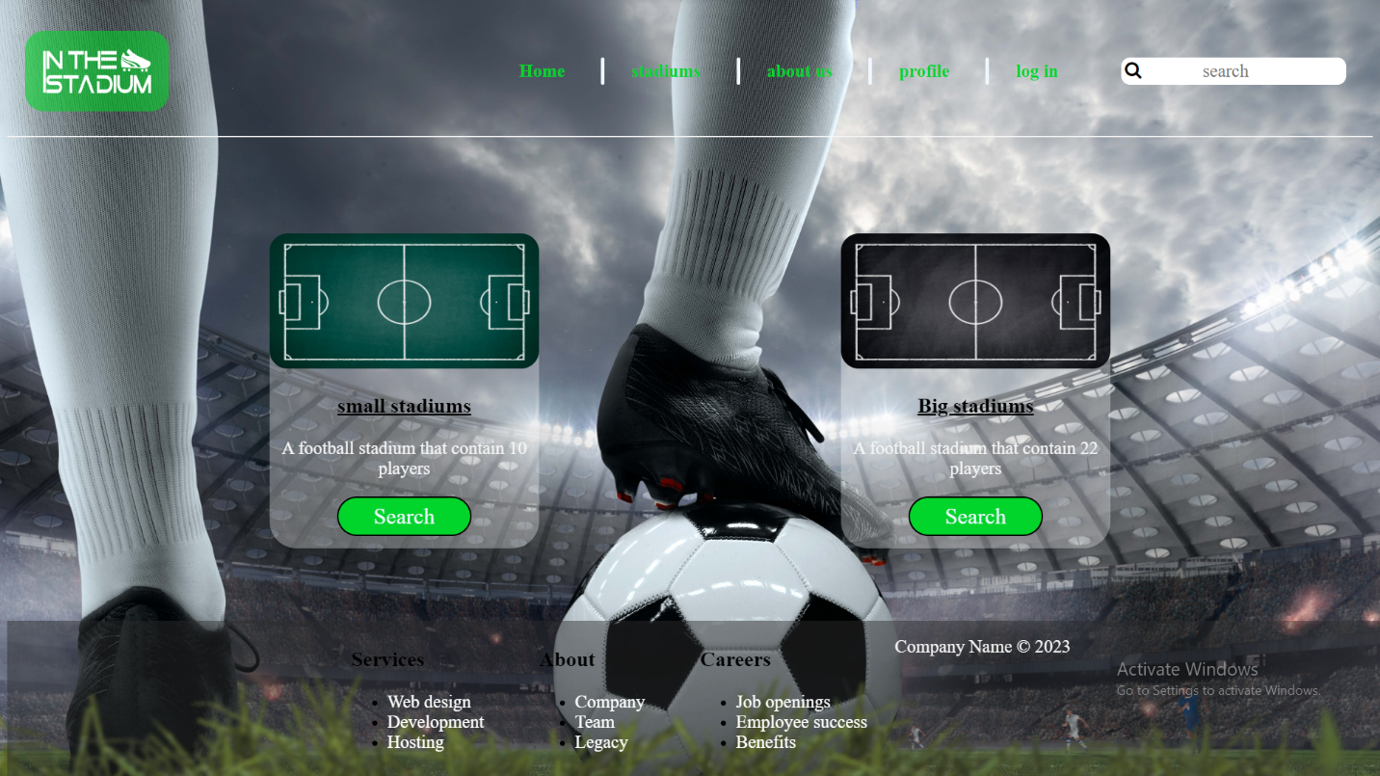

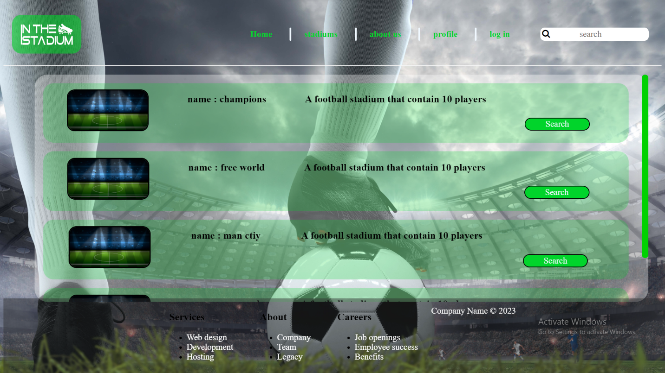

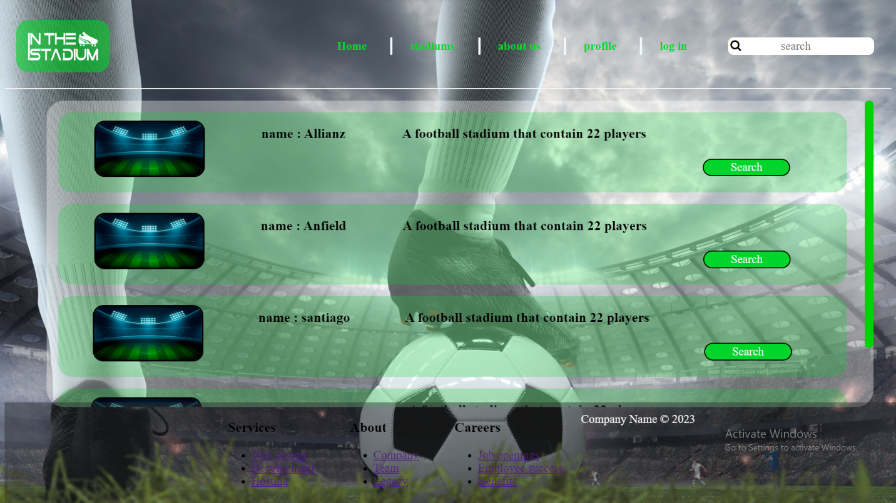

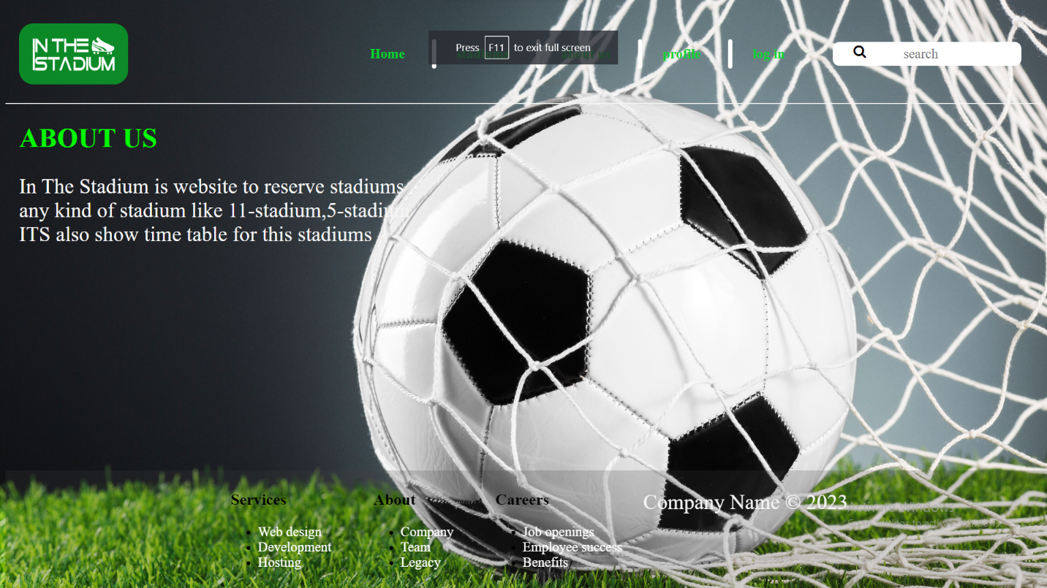

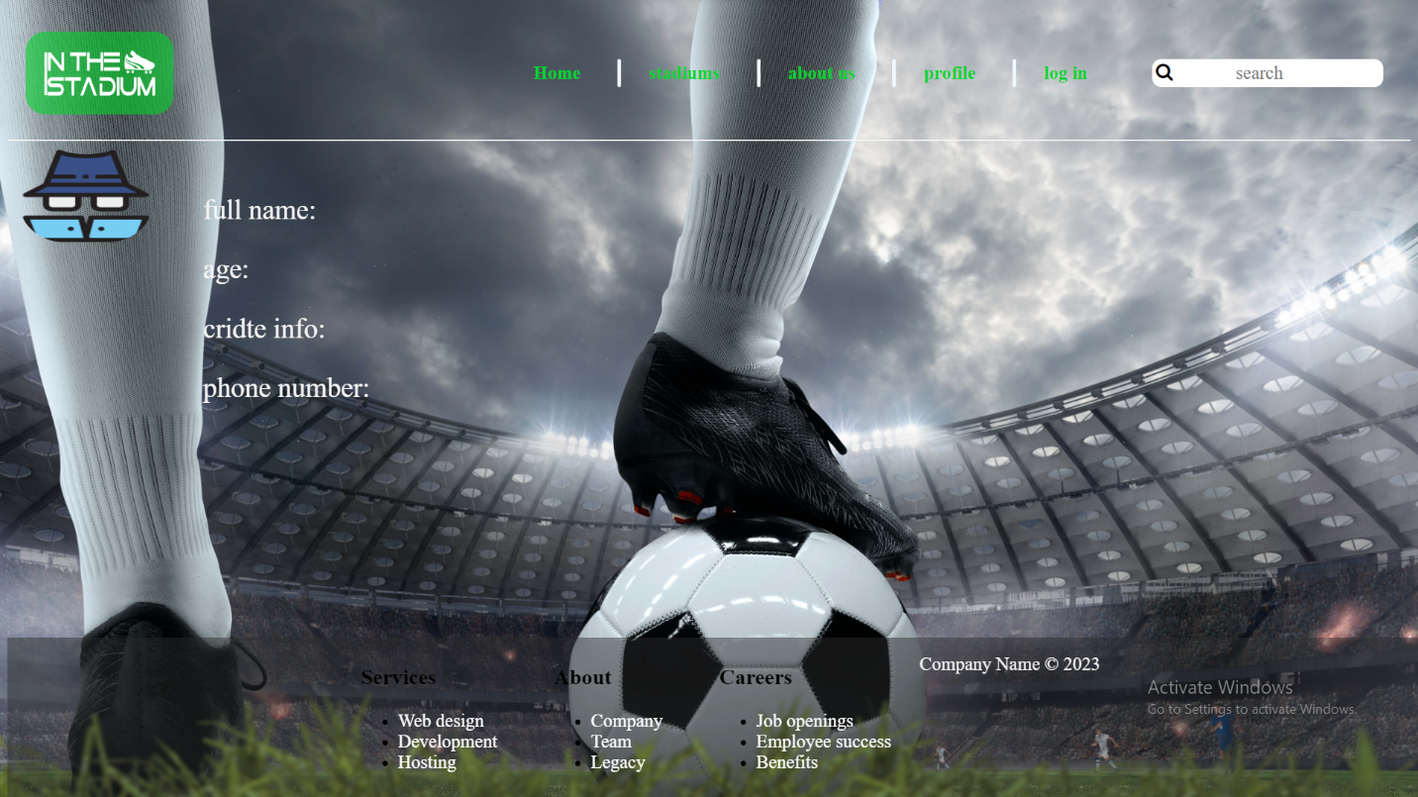

# **Summary**

So in a very few words the first target of our project is the comfort of the client so That he/she can enjoy playing football at any time without taking in concern the long Waiting moments to reserve a local stadium to play a match with his/her friends To enjoy their precious time and also to avoid the problem of busy times or Unavailable stadiums, in addition to that our client can reserve his/her favorite Stadium at any time any go through the payment with one touch as his credit card Is linked to his/her profile and verified by our system to spree the client the problem Of carrying cash money which might be lost or not good for use, in addition to our Privacy and security so that our client can feel safe and secure while assigning His/her credit card information throughout our system so what we want to say is With our website application you can enjoy football at any time with one touch.

# **References**

1. Gillis, Alexander (2021). ["What is internet of things (IoT)?"](https://internetofthingsagenda.techtarget.com/definition/Internet-of-Things-IoT). IOT Agenda. Retrieved 17 August 2021.
2. [**^**](https://en.wikipedia.org/wiki/Internet_of_things#cite_ref-Linux_21OSP_2-0) Brown, Eric (20 September 2016). ["21 Open Source Projects for IoT"](http://www.linux.com/NEWS/21-OPEN-SOURCE-PROJECTS-IOT). Linux.com. Retrieved 23 October 2016.
3. [***^***](https://en.wikipedia.org/wiki/Internet_of_things#cite_ref-IqTU_3-0)["Internet of Things Global Standards Initiative"](http://www.itu.int/en/ITU-T/gsi/iot/Pages/default.aspx). ITU. Retrieved 26 June 2015.
4. [^](https://en.wikipedia.org/wiki/Internet_of_things#cite_ref-4) Hendricks, Drew. ["The Trouble with the Internet of Things"](http://data.london.gov.uk/blog/the-trouble-with-the-internet-of-things/). London Datastore. Greater London Authority. Retrieved 10 August 2015.
5. [^](https://en.wikipedia.org/wiki/Internet_of_things#cite_ref-5) Shafiq, Muhammad; Gu, Zhaoquan; Cheikhrouhou, Omar; Alhakami, Wajdi; Hamam, Habib (3 August 2022). ["The Rise of "Internet of Things": Review and Open Research Issues Related to Detection and Prevention of IoT-Based Security Attacks"](https://doi.org/10.1155%2F2022%2F8669348). Wireless Communications and Mobile Computing. 2022: e8669348. [doi](https://en.wikipedia.org/wiki/Doi_(identifier)):[10.1155/2022/8669348](https://doi.org/10.1155%2F2022%2F8669348). [ISSN](https://en.wikipedia.org/wiki/ISSN_(identifier)) [1530-8669](https://www.worldcat.org/issn/1530-8669)
6. Beal, Vangie (1 September 1996). ["What is a Network?"](https://www.webopedia.com/definitions/network/). Webopedia. Retrieved 22 November 2022.
7. [^](https://en.wikipedia.org/wiki/Internet_of_things#cite_ref-7) [Internet of things and big data analytics toward next-generation intelligence](https://www.worldcat.org/oclc/1001327784). Nilanjan Dey, Aboul Ella Hassanien, Chintan Bhatt, Amira Ashour, Suresh Chandra Satapathy. Cham, Switzerland. 2018. p. 440. [ISBN](https://en.wikipedia.org/wiki/ISBN_(identifier)) [978-3-319-60435-0](https://en.wikipedia.org/wiki/Special:BookSources/978-3-319-60435-0). [OCLC](https://en.wikipedia.org/wiki/OCLC_(identifier)) [1001327784](https://www.worldcat.org/oclc/1001327784).
8. [^](https://en.wikipedia.org/wiki/Internet_of_things#cite_ref-8) ["Forecast: The Internet of Things, Worldwide, 2013"](https://www.gartner.com/en/documents/2625419/forecast-the-internet-of-things-worldwide-2013). Gartner. Retrieved 3 March 2022.
9. Hu, J.; Niu, H.; Carrasco, J.; Lennox, B.; Arvin, F., "[Fault-tolerant cooperative navigation of networked UAV swarms for forest fire monitoring](https://www.sciencedirect.com/science/article/pii/S1270963822001687)" Aerospace Science and Technology, 2022.
10. [^](https://en.wikipedia.org/wiki/Internet_of_things#cite_ref-aut_10-0) Hu, J.; Lennox, B.; Arvin, F., "[Robust formation control for networked robotic systems using Negative Imaginary dynamics](https://www.sciencedirect.com/science/article/pii/S0005109822000802)" Automatica, 2022.
11. [^](https://en.wikipedia.org/wiki/Internet_of_things#cite_ref-11) Laplante, Phillip A.; Kassab, Mohamad; Laplante, Nancy L.; Voas, Jeffrey M. (2018). ["Building Caring Healthcare Systems in the Internet of Things"](https://www.ncbi.nlm.nih.gov/pmc/articles/PMC6506834). IEEE Systems Journal. 12 (3): 3030–3037. [Bibcode](https://en.wikipedia.org/wiki/Bibcode_(identifier)):[2018ISysJ..12.3030L](https://ui.adsabs.harvard.edu/abs/2018ISysJ..12.3030L). [doi](https://en.wikipedia.org/wiki/Doi_(identifier)):[10.1109/JSYST.2017.2662602](https://doi.org/10.1109%2FJSYST.2017.2662602). [ISSN](https://en.wikipedia.org/wiki/ISSN_(identifier)) [1932-8184](https://www.worldcat.org/issn/1932-8184). [PMC](https://en.wikipedia.org/wiki/PMC_(identifier)) [6506834](https://www.ncbi.nlm.nih.gov/pmc/articles/PMC6506834). [PMID](https://en.wikipedia.org/wiki/PMID_(identifier)) [31080541](https://pubmed.ncbi.nlm.nih.gov/31080541).
12. [^](https://en.wikipedia.org/wiki/Internet_of_things#cite_ref-12) ["The New York City Internet of Things Strategy"](https://www1.nyc.gov/assets/cto/#/project/iot-strategy). www1.nyc.gov. Retrieved 6 September 2021.
13. © 2001 — Present. [DesignHammer, LLC](https://designhammer.com/) ~ Building Smarter Websites A Raleigh / Durham Web Design Company — [Contact Us](https://designhammer.com/contact/get-in-touch).[1912 E. HWY 54, Suite 201, Durham, NC 27713](http://maps.google.com/maps?q=Suite+201,+1912+E.+NC+Highway+54+Durham,+NC+27713,+DesignHammer&hl=en&sll=35.902553,-78.897864&sspn=0.007865,0.011641&hq=Suite+201,+1912+E.+NC+Highway+54+Durham,+NC+27713,+DesignHammer&t=m&z=17)